Department of Computer Engineering TE Computer-A (2020-21 Sem I) Computer Networks Practical Assignment A8 [Max Marks: 10]

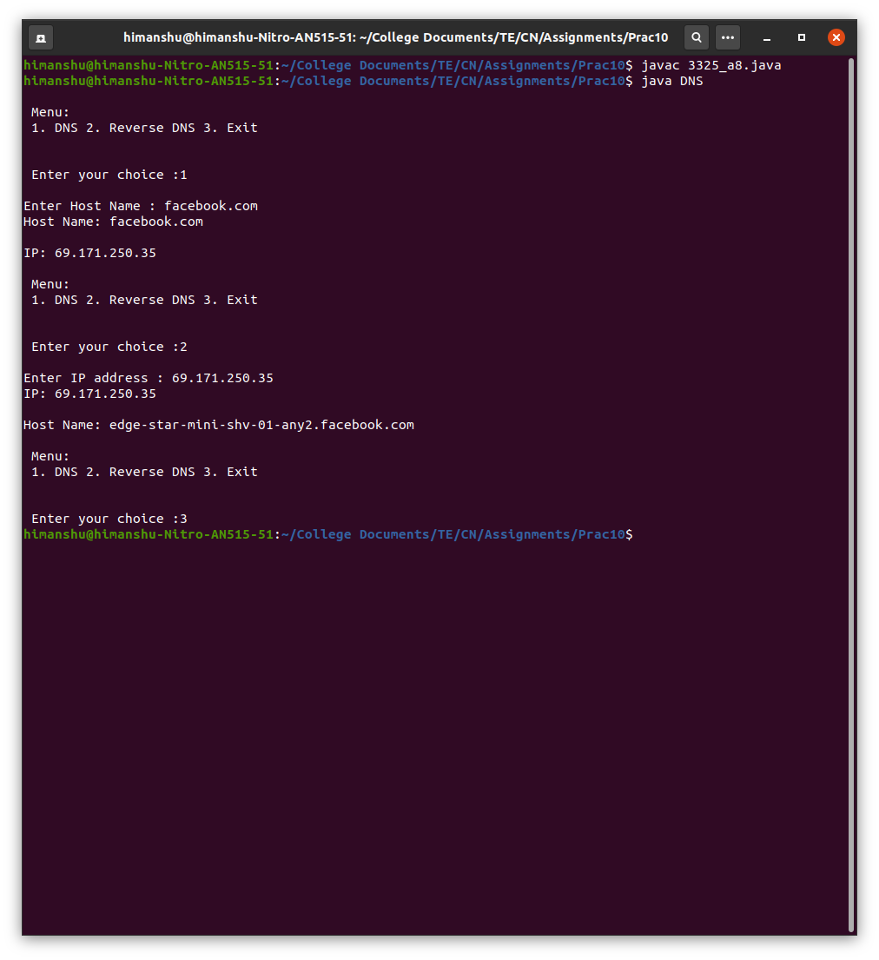
By : Himanshu Shekhar Padhi (3325)

